App and Web Servers:

- Install nginx and run nginx on port number 81.
- Deploy a sample index.html file on nginx.
- Install Apache and run Apache on port number 82
- Deploy a sample index.html file on Apache.
- Install Apache tomcat on port number 8082
- Deploy a sample app on webapps
- Create a tomcat.service file for tomcat.
- Configure HA Proxy server

Installed nginx and run nginx on port number 81.

- sudo yum install nginx
- sudo systemctl status nginx
- sudo systemctl enable nginx
- sudo systemctl status nginx
- cd /usr/share/nginx/html/
- /user/share/nginx/html
- vi index.html
- cat /etc/nginx/nginx.conf
- vi /etc/nginx/nginx.conf
- cat /etc/nginx/nginx.conf
- vi /etc/nginx/nginx.conf
- sudo systemctl restart ngin
- sudo systemctl status nginx

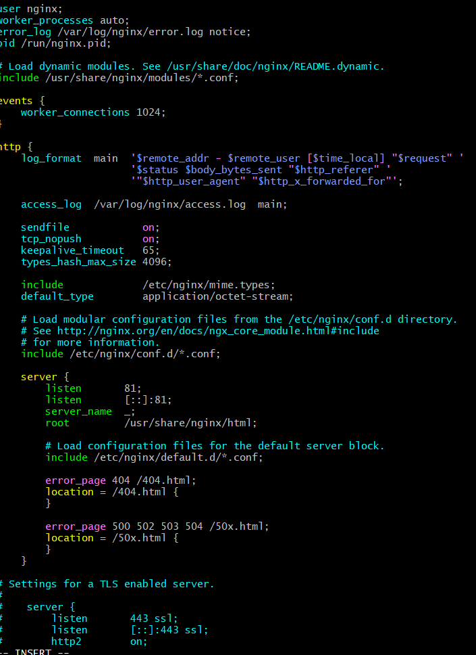


Deploy a sample index.html file on nginx.
vi index.html
sudo restart nginx
sudo systemctl restart nginx
sudo systemctl status nginx

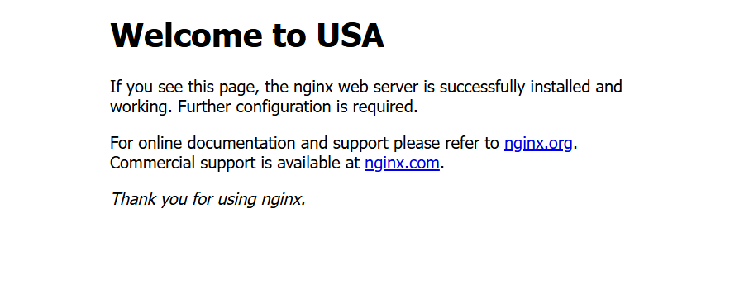

Install Apache and run Apache on port number 82
Deploy a sample index.html file on Apache.
- cd /var/www/html
- sudo vi index.html
- sudo restart httpd
- sudo systemctl restart httpd
- sudo systemctl statrt httpd
- sudo systemctl start httpd
- sudo systemctl status httpd
- cd /var/www/html
- sudo systemctl status httpd


Install Apache tomcat on port number 8082

- sudo yum install java-17-openjdk -y
- cat /etc/os-release
- sudo dnf install java-17-amazon-corretto -y
- java -version
- cd /opt
- sudo wget https://downloads.apache.org/tomcat/tomcat-10/v10.1.31/bin/apache-tomcat-10.1.31.tar.gz
- sudo tar -xvzf apache-tomcat-10.1.31.tar.gz
- cd /opt
- sudo wget https://dlcdn.apache.org/tomcat/tomcat-10/v10.1.34/bin/apache-tomcat-10.1.34.tar.gz
- sudo tar -xvzf apache-tomcat-10.1.34.tar.gz
- sudo nano /opt/tomcat/conf/server.xml
- cd /opt
- sudo wget https://dlcdn.apache.org/tomcat/tomcat-10/v10.1.48/bin/apache-tomcat-10.1.48.tar.gz
- sudo wget https://archive.apache.org/dist/tomcat/tomcat-10/v10.1.48/bin/apache-tomcat-10.1.48.tar.gz
- sudo tar -xvzf apache-tomcat-10.1.48.tar.gz
- sudo mv apache-tomcat-10.1.48 tomcat
- ls
- sudo nano /opt/tomcat/conf/server.xml

- sudo chmod +x /opt/tomcat/bin/*.sh
- cd /opt/tomcat/bin
- sudo ./startup.sh
- sudo firewall-cmd --permanent --add-port=8082/tcp
- sudo firewall-cmd --reload
- sudo nano /opt/tomcat/conf/server.xml
- cd /opt/tomcat/bin
- sudo ./startup.sh
- cd pache-tomcat-9.0,109
- ls
- sudo netstat -tulnp | grep 8082
- cd /opt/tomcat/bin
- sudo ./startup.sh
- sudo tail -f /opt/tomcat/logs/catalina.out
- sudo vi /opt/tomcat/conf/server.xml
- curl http://localhost:8082
- sudo netstat -tulnp | grep 8082
- sudo tail -20 /opt/tomcat/logs/catalina.out
- sudo vi /opt/tomcat/conf/server.xml
- cd /opt/tomcat/bin
- sudo ./startup.sh
- sudo tail -f /opt/tomcat/logs/catalina.out
- sudo netstat -tulnp | grep 8082
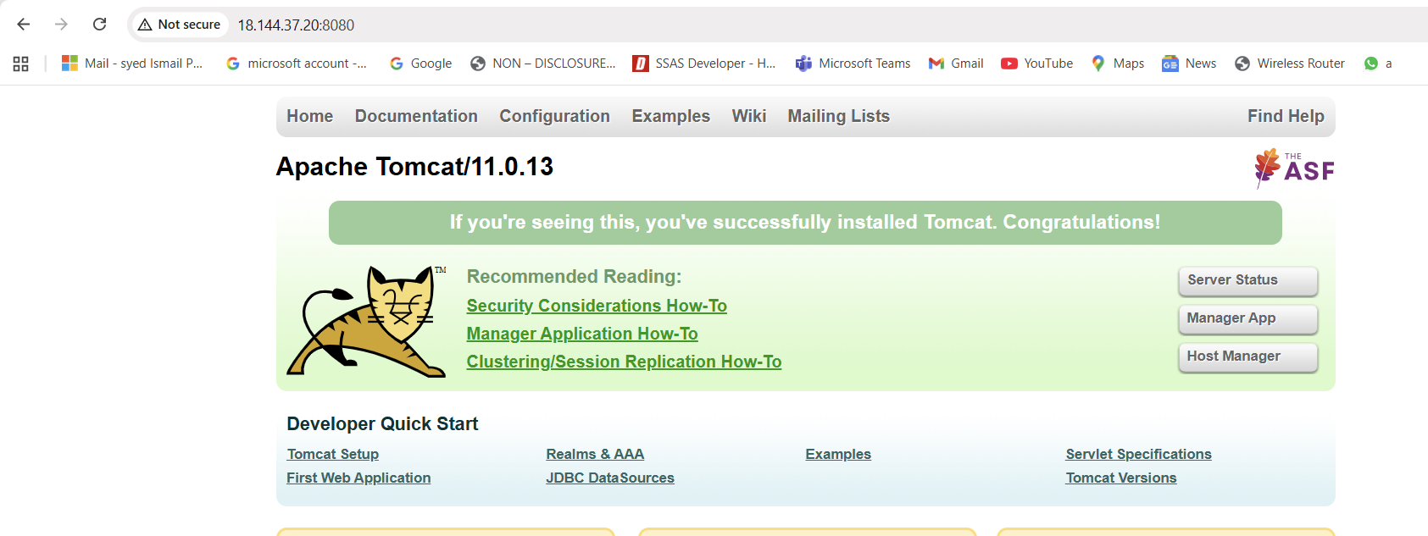

Deploy a sample app on webapps

- Procedure: Deploy a Sample Application on Tomcat Webapps
Go to the Tomcat webapps directory
cd /opt/apache-tomcat-9.0.111/webapps
Create a new application folder
mkdir sample
Move inside the newly created application directory
cd sample
Create an index.jsp file using vi
vi index.jsp
- Press i to enter insert mode and paste sample JSP content**
<!DOCTYPE html>
<html>
<body>
<h1>Tomcat Application Running Successfully</h1>
</body>
</html>
Save and Exit the file
Press Esc
Type:
:wq
Press Enter
Restart Tomcat to load the new application
cd /opt/apache-tomcat-9.0.111/bin
./shutdown.sh
./startup.sh
Verify the application in browser
http://<server-public-ip>:8082/sample/
• Create a tomcat.service file for tomcat.
Procedure: Create & Enable tomcat.service File
Create a new service file for Tomcat
sudo vi /etc/systemd/system/tomcat.service
Press i to enter insert mode, then paste the following:
[Unit]
Description=Apache Tomcat Server
After=network.target
- [Service]
Type=forking
Environment=CATALINA_HOME=/opt/apache-tomcat-9.0.111
Environment=CATALINA_BASE=/opt/apache-tomcat-9.0.111
Environment=CATALINA_PID=/opt/apache-tomcat-9.0.111/temp/tomcat.pid
ExecStart=/opt/apache-tomcat-9.0.111/bin/startup.sh
ExecStop=/opt/apache-tomcat-9.0.111/bin/shutdown.sh
Restart=on-failure
[Install]
WantedBy=multi-user.target
Save and exit
Press Esc
Type:
:wq
Press Enter
Reload systemd to recognize the new service
sudo systemctl daemon-reload
Enable Tomcat to start on boot
sudo systemctl enable tomcat
Start Tomcat service
sudo systemctl start tomcat
Check service status
sudo systemctl status tomcat
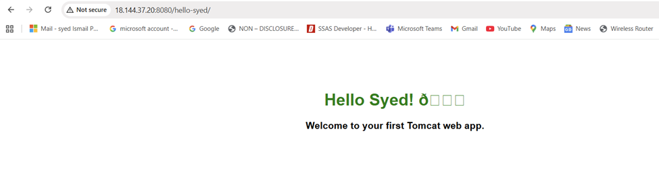

Configure HA Proxy server

Launch 3 ec2 instances name as Server1, Server-2, HA-Proxy-Server.
• Executed following command to Access the Server-1
• ssh -i your-key.pem ec2-user@Pubipaddress of Server-1 instance
• sudo -i
• yum update -y
• Yum install httpd -y
• Vi /etc/hosts
• Add HA-Proxy-Server Pubic IP Address
• Run below command on Server-1
• ping load_balancer -c 4
• systemctl start httpd
• systemctl status httpd
• Browse with Server-1 Public IP address:80 it will work
Server-2 Steps:
rowse with Server-1 Public IP address:80 it will work
Server-2 Steps:
Run following command to Access Server-2
•ssh -i your-key.pem ec2-user@Pubipaddress of Server-2 instance
•sudo -i
•yum update -y
•yum install nginx -y
•sudo amazon-linux-extras install nginx1 -y
•vi /etc/hosts
•Add HA-Proxy-Server Pubic IP Address
Run below command on Server-2
ping load_balancer -c 4
•systemctl start nginx
•systemctl status nginx
Browse with Server-2 Public IP address:80 it will work
HA-Proxy-Server Steps:
Run following command to Access HA-Proy-Server
•ssh -i your-key.pem ec2-user@Pubipaddress of HA-Proxy-Server instance
•sudo -i
•yum update -y
•yum install haproxy -y
•vi /etc/hosts
•Add Server-1, Server-2 Public IP’s
•vi /etc/haproxy/haproxy.cfg
•Add Server-1, Server-2 public IP’s
•systemctl enable haproxy
•systemctl start haproxy
•systemctl status haproxy
•now browse with HA-Proxy-Server PublicIP:80 it will distribute load to

